Cluster 1 –Factors and Products
Independent practice Name :

Outcomes:
A1 – Demonstrate an understanding of factors of whole numbers by determining prime factors, LCM, GCF, square roots and cube roots
A4 – Demonstrate an understanding of the multiplication of polynomial expressions
A5 – Demonstrate an understanding of common factors and trinomial factoring

Throughout this unit I will be increasing number sense and algebraic reasoning:

- I can write a number as a product of its prime factors (A1)
- I can use prime factorization to determine the greatest common factor (GCF) of two numbers (A1)
- I can use prime factorization to determine the least common multiple (LCM) of two numbers (A1)
- I can use prime factorization to determine the square and cube root of a number (A1)
- I can multiply binomials and other polynomials (A4)
- I can factor trinomials of the form (A5):
  - $x^{2} + bx + c$
  - $ax^{2} + bx + c$
  - $(a + b)^{2}$
  - $(a – b)^{2}$
  - $a^{2} – b^{2}$
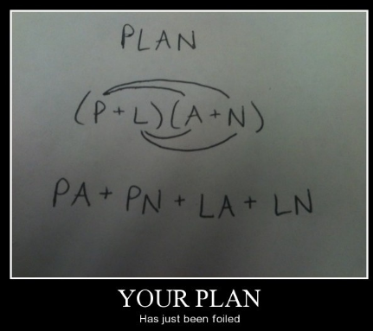

Lesson 1 - Factors and Multiples of Whole Numbers

- List the prime factors of each number:
- 40 b. 75 c. 81

d. 120 e. 140 f. 192

- Use powers to write each number as a product of its prime factors:
- 600 b. 1150

c. 2250 d. 4500

- Explain why the numbers 0 and 1 have no prime factors.

- Determine the greatest common factor of each pair of numbers using prime factorization:
- 46, 84 b. 64, 120

c. 81, 216 d. 180, 224

- Determine the least common multiple of each pair of numbers using prime factorization:
- 12, 14 b. 21, 45

c. 32, 45 d. 28, 52

- Two marching bands are to be arranged in rectangular arrays with the same number of columns. One band has 42 members, the other has 36 members. What is the greatest number of columns in the array?

- What are the dimensions of the smallest square that could be tiled using an 18-cm by 24-cm tile? Assume the tiles cannot be cut.

- A developer wants to subdivide this rectangular plot of land into congruent square pieces. What is the side length of the largest possible square?

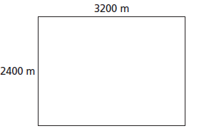

- Do all whole numbers have at least one prime number? Explain.

Need more practice? Page 140 of the textbook has more questions like these
Lesson 2 - Perfect Squares, Perfect Cubes and Their Roots

- Determine the square root of each number using prime factorization:
- 324 b. 256

c. 625 d. 900

- Determine the cube root of each number using prime factorization:
- 216 b. 512

c. 1000 d. 3375

- Use prime factors to determine if each number is a perfect square, a perfect cube or neither.
- 729 b. 1444

- 64 d. 216

- Determine the side length of each square without using a calculator:
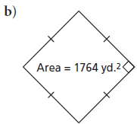
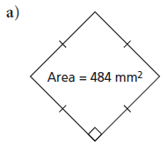

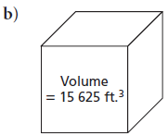
- Determine the edge length of each cube (Calculator OK)
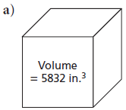
- In February 2003, the Chamber of Commerce in Saskatchewan places a cage containing a 64 cubic foot ice cube along the Yellowhead Highway. Local customers were asked to predict when the ice cube would melt enough for a ball above the ice cube to fall through it. What was the surface area of the cube?

- A cube has a surface area of 6534 square feet. What is its volume? (Caclulator OK)

- Is it possible to construct a cube with 2000 interlocking cubes? Justify your answer.

- Determine all the perfect square whole numbers and perfect cube whole numbers between each pair of numbers (Calculator OK):

- 315 -390

- 800 - 925

More practice is on page 146 of your textbook.
Lesson 3 - Mulitplying Polynomials

Expand and simplify
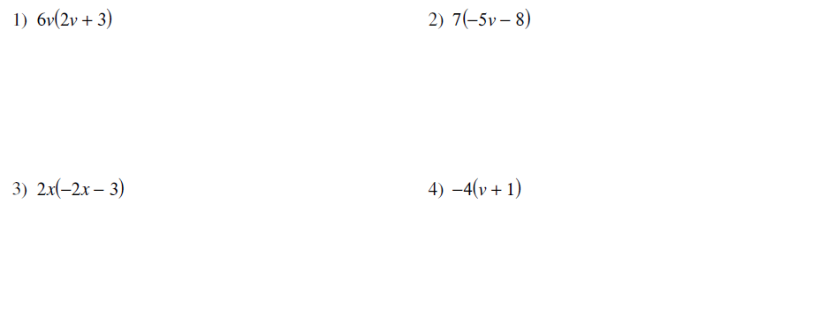
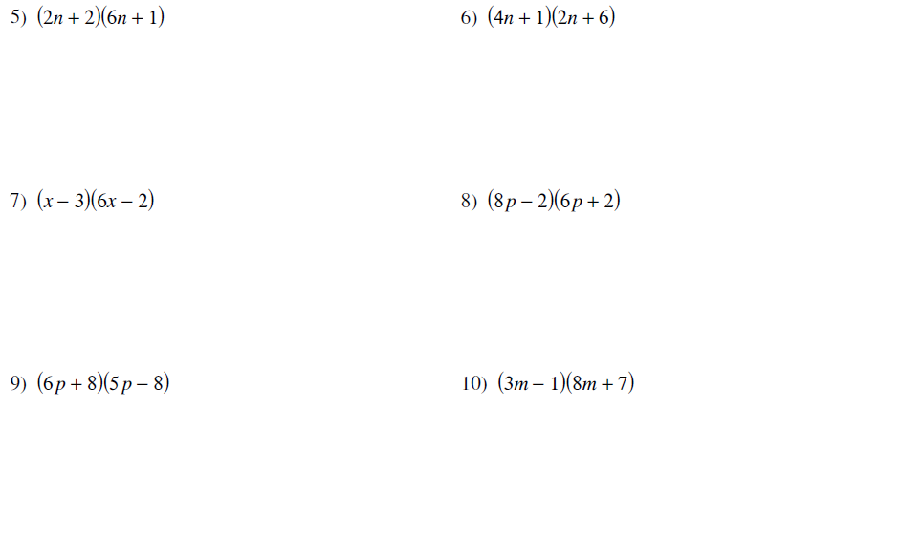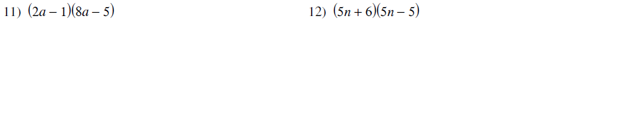
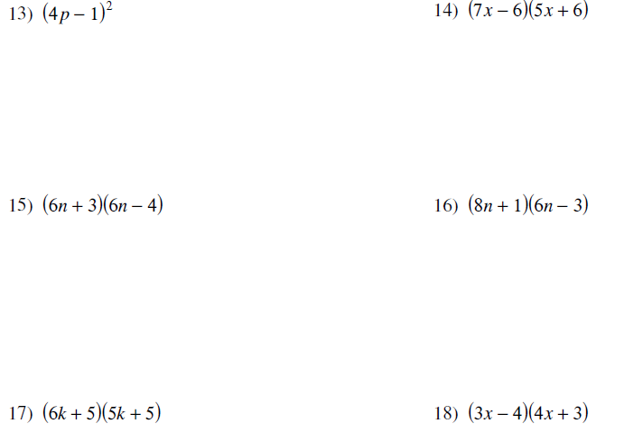

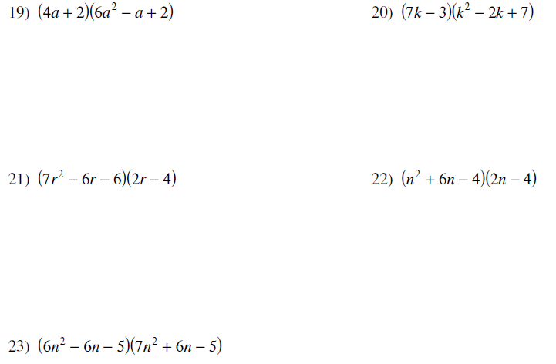

- A box with no top is made from a piece of cardboard 20 cm by 10 cm. Equal squares are cut from each corner and the sides are folded up.
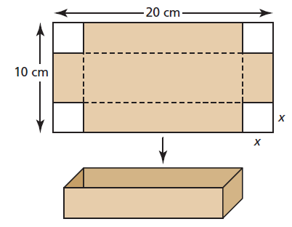
Let x centimetres represent the side length of each square cut out. Write a polynomial to represent each measurement. Simplify each polynomial:

- the length of the box

- the width of the box

- the area of the base of the box

- the volume of the box

- Each shape is a rectangle. Write a polynomial to represent the area of each shaded region. Simplify each polynomial:
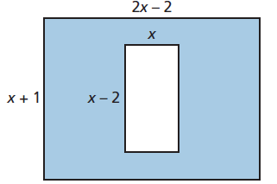
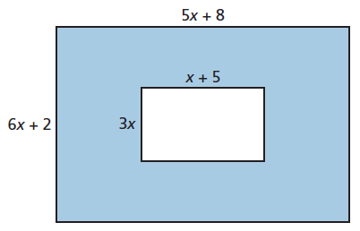
- b)

Need more practice? Page 186 of the textbook has more questions like these.
Lesson 4 – Factoring a Greatest Common Factor

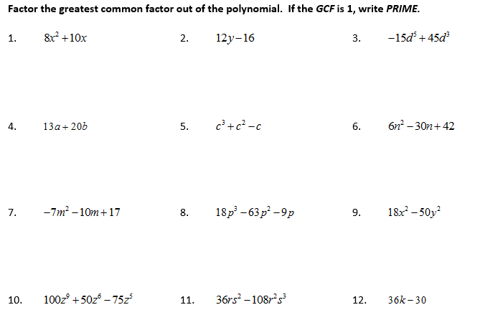

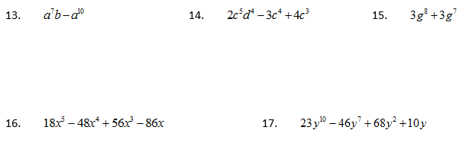

Need more practice? Page 155 of your textbook has more questions like these.
Lesson 5 – Factoring Quadratics The “Easy Way”
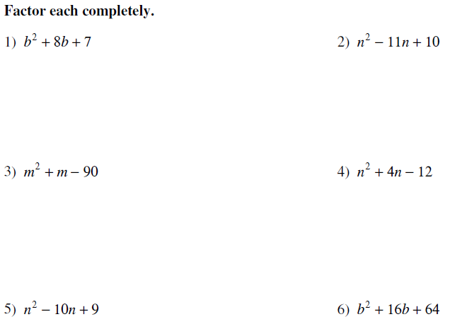

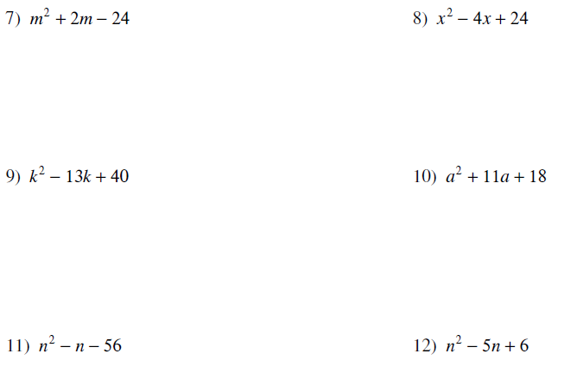
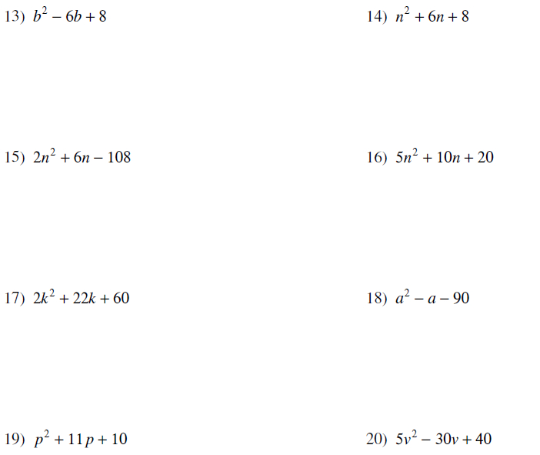

Need more practice? Page 166 of the textbook has more questions like these.
Lesson 6 – Factoring Using Decomposition

Need more practice? Page 177 of the textbook has more questions like these
Lesson 7 – Factoring Special Polynomials
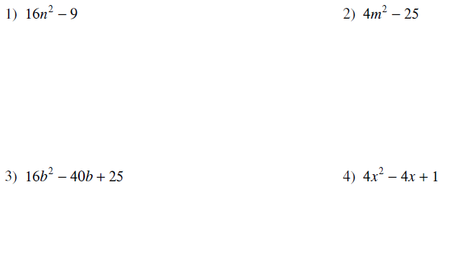
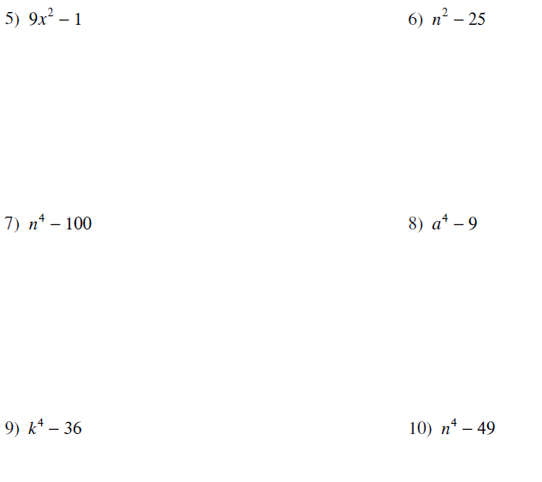

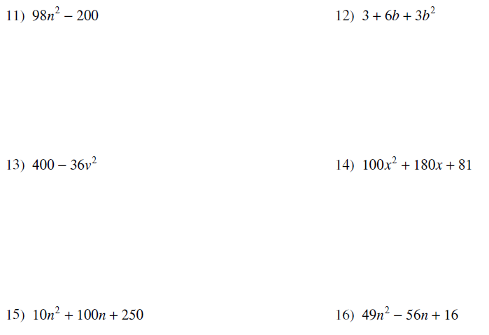

Answers

Lesson 1 - Factors and Multiples of Whole Numbers
1. a. 2, 5 b. 3, 5 c. 3 d. 2, 3, 5 e. 2, 5, 7 f. 2, 3
2. a. 2³ x 3 x 5³ b. 2 x 5² x 23 c. 2 x 3² x 5³ d. 2² x 3² x 5³
4. a. 2 b. 8 c. 27 d. 4
5. a. 84 b. 315 c. 1440 d. 364
6. 6
7. 72 cm by 72 cm
8. 800 m
9. No, 1 does not have any prime factors

Lesson 2 - Perfect Square, Perfect Cubes and Their Roots
1. a. 18 b. 16 c. 25 d. 30
2. a. 6 b. 8 c. 10 d. 15
3. a. both b. perfect square c. both d. perfect cube
4. a. 22 b. 42
5. a. 18 b. 25
6. 96 ft²
7. 35 937 ft³
8. No, 2000 is not a perfect cube
9. a. perfect squares: 324, 361 perfect cubes: 343
b. perfect squares: 841, 900

Lesson 3 – Multiplying Polynomials
1. 12v² +18v 2. -35v – 56 3. -4x² – 6x 4. -4v – 4
5. 12n² + 14n +2 6. 8n² +26n + 6 7. 6x² – 20x +6 8. 48p² + 4p – 4
9. 30p² -8p - 64 10. 24m² + 13m -7 11. 16a² - 18a +5 12. 25n² +5n -30
13. 16p² – 8p +1 14. 35x² +12x -36 15. 36n² -6n -12 16. 48n² – 18n – 3
17. 30k² +55k +25 18. 12x² – 7x – 12 19. 24a³ +8a² + 6a 20. 7k³ -17k² +55k -21
21. 14r³ -40r² +12r +24 22. 2n³ +8n² -32n + 16
23. a) 20 – 2x b) 10 – 2x c) 4x² – 60x + 200 d) 4x³ – 60x² + 200x
24. a) 27x² + 43x + 16 b) x² + 2x – 2

Lesson 4 – Factoring a Greatest Common Factor
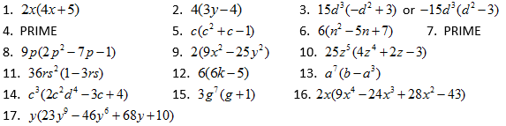

Lesson 5 – Factoring Quadratics The “Easy Way”
1. (b +7)(b+ 1) 2. (n -10)(n – 1) 3. (m – 9)(m +10) 4. (n -2)(n +6)
5. (n -1)(n – 9) 6. (b +8)(b +8) 7. (m +6)(m – 4) 8. Not factorable
9. (k -5)(k – 8) 10. (a +2)(a +9) 11. (n +7)(n – 8) 12. (n -2)(n – 3)
13. (b – 4)(b – 2) 14. (n +2)(n +4) 15. 2(n +9)(n – 6) 16. 5(n² +2n +4)
17. 2(k +5)(k +6) 18. (a – 10)(a +9) 19. (p +10)(p + 1) 20. 5(v – 2)(v – 4)
21. 2(p -1)(p +2) 22. 4(v +1)(v -2) 23. (x -10)(x – 5) 24. (v – 5)(V -2 )

Lesson 6 Factoring Using Decomposition 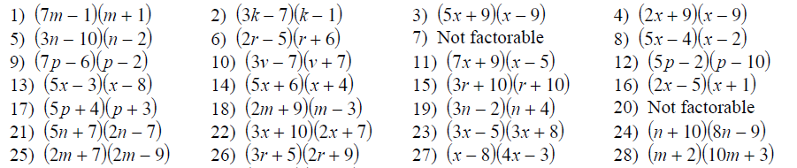

Lesson 7 – Factoring Special Polynomials
- (4n -3)(4n + 3) 2) (2m -5)(2m+5) 3) (4b – 5)(4b – 5) 4) (2x – 1)(2x -1)
5) (3x -1)(3x + 1) 6) (n – 5)(n + 5) 7) (n² – 10)(n² + 10) 8) (aª – 3)(a² +3)
9) (k² – 6)(k² + 6) 10) (n² – 7)(n² + 7) 11) 2(7n +10)(7n -10) 12) 3(b + 1)(b +1)
13) 4(10 – 3v)(10 + 3v) 14) (10x +9)(10x + 9) 15) 10 (n +5)(n +5) 16) (7n – 4)(7n – 4)
17) (7x – 10)(7x + 10) 18) (1 – r)(1 + r) 19) 10p(p – 14)(p + 14) 20) (7 – b²)(7 + b²)

