Cluster 1 –Factors and Products

Outcomes:
A1 – Demonstrate an understanding of factors of whole numbers by determining prime factors, LCM, GCF, square roots and cube roots
A4 – Demonstrate an understanding of the multiplication of polynomial expressions
A5 – Demonstrate an understanding of common factors and trinomial factoring

Throughout this unit I will be increasing number sense and algebraic reasoning:

- I can write a number as a product of its prime factors (A1)
- I can use prime factorization to determine the greatest common factor (GCF) of two numbers (A1)
- I can use prime factorization to determine the least common multiple (LCM) of two numbers (A1)
- I can use prime factorization to determine the square and cube root of a number (A1)
- I can multiply binomials and other polynomials (A4)
- I can factor trinomials of the form (A5):
  - $x^{2} + bx + c$
  - $ax^{2} + bx + c$
  - $(a + b)^{2}$
  - $(a – b)^{2}$
  - $a^{2} – b^{2}$
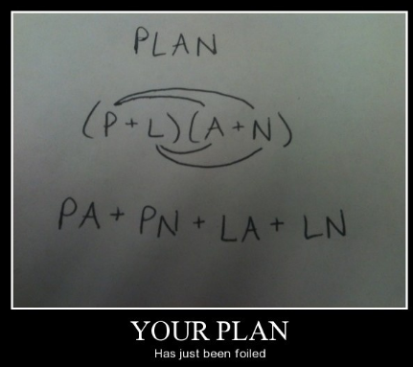

Unit 1 – Factors and Products

Lesson 1 - Factors and Multiples of Whole Numbers

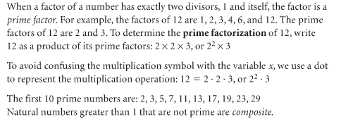
Write the prime factorization of 540

Try: Write the prime factorization of 3600

The greatest common factor is:

Determine the greatest common factor of 138 and 198

Try: Determine the greatest common factor of 126 and 144

The least common multiple is:

Determine the least common multiple of 18, 20 and 30

Try: Determine the least common multiple of 28, 42, 63

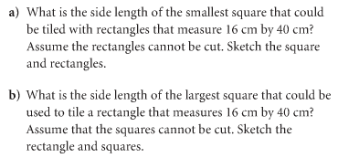

Try:
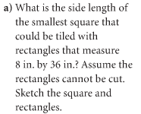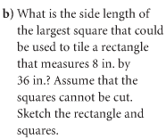

Lesson 2 - Perfect Squares, Perfect Cubes and Their Roots

Perfect Square:

The first 20 perfect squares are:

Perfect Cube:

The first 5 perfect cubes are:

Determine the square root of 1296

Try: Determine the square root of 1024

Determine the cube root of 1728

Try: Determine the cube root of 3375

A cube has a volume of 4913 cubic inches. What is the surface area of the cube?

Try: A cube has a volume of 12 167 cubic feet. What is the surface area of the cube?

Lesson 3 - Multiplying Polynomials

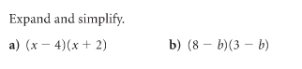

Try:
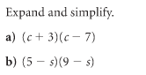

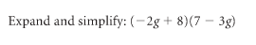
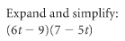
Try:

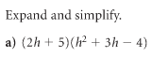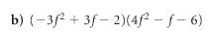

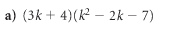
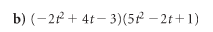
Try:

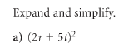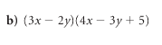

Try:
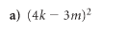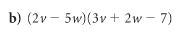

Expand and simplify:

Activity: Factoring Polynomials Using Algebra Tiles

Use algebra tiles to factor each binomial. Draw a picture of your result. Write your answer in the space provided.
1. 3x + 9 2. 4x − 10

Answer:_______________ Answer:_______________

3. 3x² + 4x 4. 10 − 5x

Answer:_______________ Answer:_______________
5. 3 − 9x 6. x² − 5x

Answer:_______________ Answer:_______________

7. 2x² + 6x 8. x² + 5x

Answer:_______________ Answer:_______________

Lesson 4 - Factoring a Greatest Common Factor

Factoring a polynomial means to break the polynomial down into the product of smaller polynomials (it’s the reverse of multiplying polynomials)

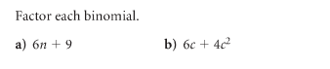
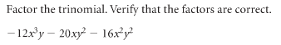

Try:
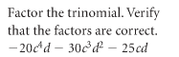

Lesson 5 – Factoring Quadratics The “Easy Way”
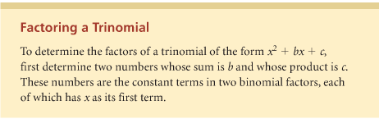

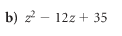
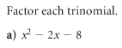

Try:
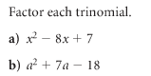
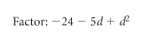
Try:

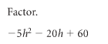
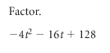
Try:

Lesson 6 – Factoring Using Decomposition
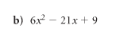
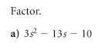
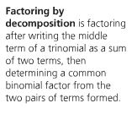

Try:

Lesson 7 - Factoring Special Polynomials
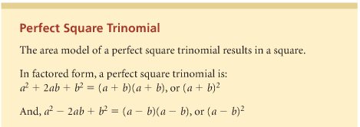

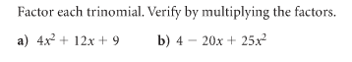

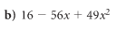
Try:

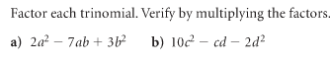

Try:

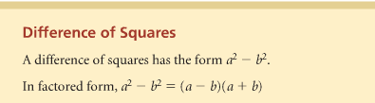
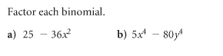

Try:
