Unit 1 – Quadratic Functions and Equations

I will develop algebraic and graphical reasoning through the study of quadratic functions:
- I can identify the features of a quadratic, including:
  - The vertex
  - The intercepts
  - The domain and range
  - The axis of symmetry
- I can use the structure of the quadratic function to determine its features
- I can describe the relationship between the roots of an equation, the zeros of a function and the x-intercepts of the graph
- I can use technology to find the vertex of a function and determine the maximum and minimum values
- I can use technology to solve a problem involving a quadratic function and apply the features of the function to the real world context

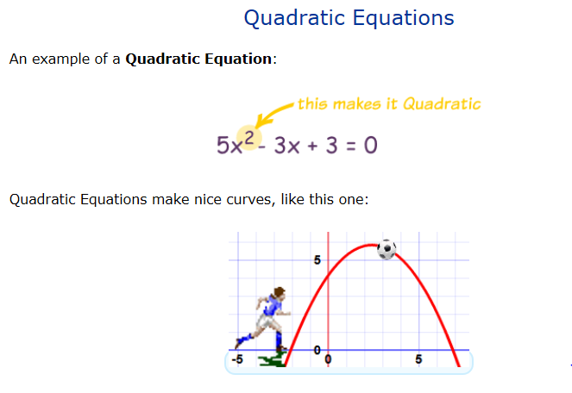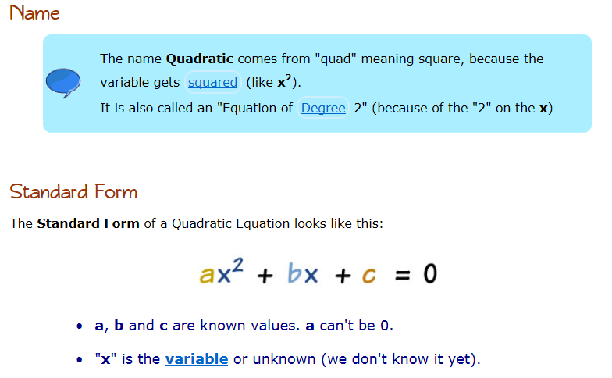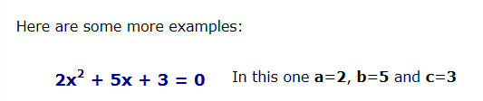
Lesson 1

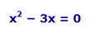
Here are some more examples. Are they quadratics?

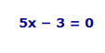
The “Mother Graph”

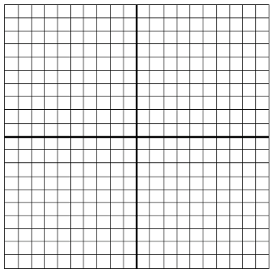

Activity:
In Desmos, enter the equation: $ax^{2}$. Add a slider.
Play with the slider and answer the following questions. Include a sketch of what you see:

- What happens when “a” = 0?

- What happens when “a” is positive?

- What happens when “a” is negative?

- What happens when “a” is larger than one?

- What happens when “a” is between 0 and 1?

- What happens when you change “b”? Be specific.

- What happens when you change “c”? Be specific.

Lesson 2 - properties of quadratics…

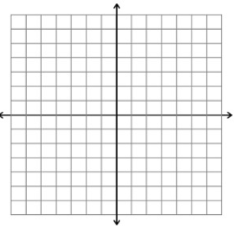
EX. Graph the following function and sketch its graph: $y=x^{2}+2x-2$

What is the y-intercept?

Does this parabola have a minimum or maximum?

What is the vertex?

What is the equation for the axis of symmetry?

What is the domain of the function? What is the range of the function?

EX. Graph the following function and sketch its graph: $y=-2x^{2}+6x$
Does this parabola have a minimum or maximum?

What is the y-intercept?

What is the equation for the axis of symmetry?

What is the vertex?

What is the domain of the function?

What is the range of the function?
EX. Some children are playing at the local splash pad. The water jets spray water from ground level. The path of water from one of these jets forms an arch that can be defined by the function:

$f\left(x\right)=-0.12x^{2}+3x$

where $x$ represents the horizontal distance from the opening in the ground in feet and $f\left(x\right)$ is the height of the sprayed water, also measured in feet. What is the maximum height of the arch of the water, and how far from the opening in the ground can the water reach?

Graph using technology, sketch the graph:
Include in all sketches:
- Label the axes, include units
- Title
- Appropriate shape
- Appropriate domain
- Appropriate range
- Consistent points (maximum, minimum)

What is the equation for the axis of symmetry?

What is the maximum? What does it represent?

What is the domain of the function?

What is the range of the function?

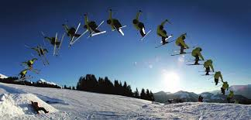
EX. The skier’s coach used the picture to the right to determine the quadratic function that relates the skier’s height above the ground, y, measured in metres, to the time, x, in seconds that the skier was in the air:

$$y=-4.9x^{2}+15x+1$$

Graph the function. Sketch a graph of the function.

Determine the skier’s maximum height, to the nearest tenth of a metre.

State the range of the function for this context

On the next day of training, the coach asked the skier to increase his speed before taking the same jump. At the end of the day, the coach analyzed the results and determined the equation that models the skier’s best jump:
$$y=-4.9x^{2}+20x+1$$

How much higher did the skier go on this jump?

What features of a function determine whether a parabola has a minimum value or a maximum value?

How do the domain and range of the function change as the type of question changes?

Lesson 3 - Solving quadratic equations in Standard form

Standard form: the form of a quadratic we have been using so far: $y= ax^{2}+bx+c$

EX. Bonnie launches a model rocket from the ground with an initial velocity of 68 m/s. The following function, h(t) can be used to model the height of the rocket, in metres, over time, t, in seconds:

$$h\left(t\right)= -4.9t^{2}+68t$$

Bonnie’s friend, Sasha is watching from a lookout point at a safe distance. Sasha’s eye level is 72 m above the ground. How can you determine times when the rocket will be at Sasha’s eye level?

Two strategies:

Create one quadratic equation:

Graph two equations:

What are the solutions when solving a quadratic by graphing?
EX. The flight time for a long distance water-ski jumper depends on the initial velocity of the jump and the angle of the ramp. For one particular jump, the ramp has a vertical height of 5 m above water level. The height of the ski jumper in flight, h(t), in metres, over time, t, in seconds, can be modelled by the following function:

$$h\left(t\right)=5.0+24.46t-4.9t^{2}$$

How long does the water ski jumper hold his flight pose?

EX. Determine the roots of this quadratic equation.
What are roots and how do you find them?

$3x^{2}-6x+5=2x(4-x)$

Lesson 4 - Factored Form of a Quadratic Function

Factored form of a quadratic: the reason we did all that factoring last year! Looks like two binomials.

$y=a(x-r)(x-s)$, where r and s are the roots of the function

EX. Consider the following quadratic $f\left(x\right)=2x^{2}+14x+12$

In factored form the quadratic looks like:

State the domain and range of the function.

open up or down?

zeros/roots:

y-intercept:

axis of symmetry:

vertex:

We can use the graph of a quadratic to write the equation of a parabola in factored form:

EX. Determine the equation of a quadratic function, given its graph.

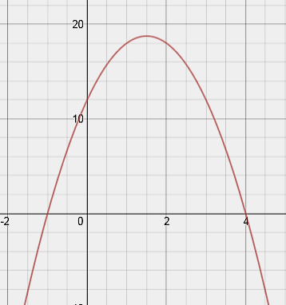

Try it on your own: What is the equation for the following graph?

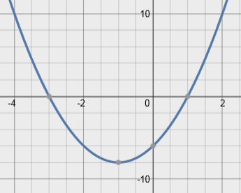

THE AREA PROBLEM
EX. Lamont runs a boarding kennel for dogs. He wants to construct a rectangular play space for the dogs, using 40 m of fencing and an existing fence as one side of the play space.
- Write a function that describes the area, A, in square metres, of the play space for any width, w, in metres

- What is the maximum area that Lamont can have for his dogs?

The costing problem
EX. Solving a problem modelled by a quadratic function in factored form.

The members of a Ukrainian church hold a fundraiser every Friday night in the summer. They usually charge $6 for a plate of perogies. They know, from previous Fridays, that 120 plates of perogies can be sold at the $6 price, but for each $1 price increase, 10 fewer plates will be sold. What should the members charge if they want to raise as much money as they can for the church?

Try it on your own: A business class at a high school operates a small T-shirt business. Over the last few years, the shop has had monthly sales of 300 T-shirts at a price of $15 per shirt. The students have learned that for every $2 price increase, they will sell 20 fewer T-shirts each month. What should they charge for their T-shirts to maximize their monthly revenue?

Lesson 5 - Vertex Form of a Quadratic Function

Quadratic functions can be written in different forms. So far, we have been looking at the standard form of a quadratic. There is another, equally helpful, form.

First, let’s remember what the “mother graph” looks like: $y=x^{2}$. Now, let’s make some changes to the graph and see what happens.

a)$y=(x-3)^{2}$ | b) $y=x^{2}-5$
c) $y=(x+1)^{2}-2$ | - $y=(x+4)^{2}+6$
- $y=-2(x+1)^{2}+3$ | $$f) y=3(x-2)^{2}-4$$

What connection can you make between the equation in vertex form and the graph of the quadratic?

The other form of a quadratic function is the vertex form.
Vertex form looks like: $y=a(x-h)^{2}+k$ where the vertex of the parabola is $\left(h, k\right).$
(Some people use $(p, q)$ – that’s ok too!)

EX. Sketching a graph of a quadratic function given in vertex form

Sketch the graph of the following function: $f\left(x\right)=2(x-3)^{2}-4$. State the domain and range of the function.

Try it on your own: Sketch: $f\left(x\right)=- \frac{1}{2}(x+6)^{2}+1$. State the domain and the range of the function.

EX. Solving a problem that can be modelled by a quadratic function
A soccer ball is kicked from the ground. After 2 s, the ball reaches a maximum height of 20 m. It lands on the ground at 4 s.

- Determine the quadratic function that models the height of the kick.

- Determine any restrictions that must be placed on the domain and the range of the function.

- What was the height of the ball at 1 s? When was the ball at the same height on the way down?

EX. Reasoning the number of zeros that a quadratic function will have

Randy claims that he can predict whether a quadratic function will have zero, one or two zeros if the function is expressed in vertex form. How can you show that he is correct?

More Problems to Solve….

The product of two consecutive integers is 30. Write a quadratic equation to represent this statement and solve.

Two consecutive integers are squared. The sum of these squares is 365. What are the integers?

Lesson 6 - Quadratic regressions

We can ask Demos to make the quadratic function from a set of points by performing a regression on the data we put into a table.

Regression formula for a quadratic function: $y_{1} \sim ax_{1}^{2}+bx_{1}+c$

EX. Determine the quadratic equation that fits the following data:

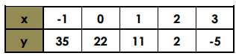

EX. Avery recorded the distance and height of a basketball when shooting a free throw. He entered the data into the following table:
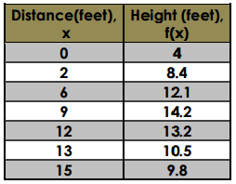
- Find the quadratic equation for the relationship between the horizontal distance and the height of the ball.

- Using this function, what is the approximate height of the ball?

EX. This table show the population of a city every ten years since 1970.
- Find the best-fitting quadratic model for the data.
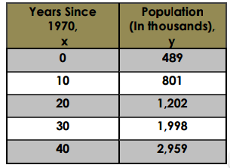

- Using this model, what will be the estimated population in 2020?

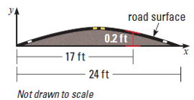
EX. The surfaces of some roads are shaped like parabolas to allow rain to run off to either side. Write the quadratic model for the surface of the road shown.

